Professor Dr. Ronald Eaglin   
Assignment 4 – CEN3722   
10/02/2023   
Group Members: Jobiya Shimul, Leslie Boykin, David Racine, David Lopez, and Juan Pellot   
Project: Catered Fitness

Catered Fitness Report

1. User will enter into their Catered Fitness application.

1.1. If there is an existing user, they will click Returning User.

1.2. If new user, they will click get started.

1.1.1 Existing users will input their login information. Once logged in they will go to their home page (3.1).

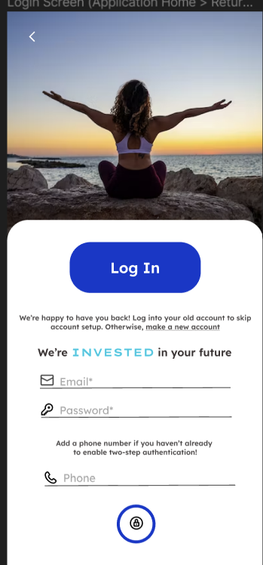

1.2.1 New users will create an account.

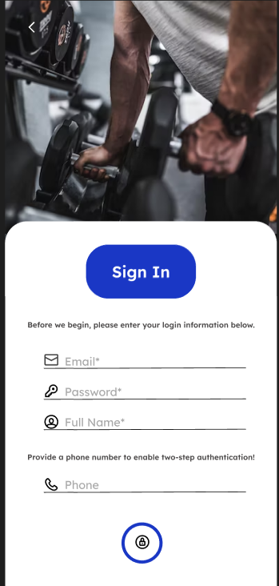

2. Once logged into the user’s account. They will select a fitness plan.

2.1. The user will select desired fitness goal focus.

2.2. The user will select upper body.

2.3. The user will select lower body.

2.2.1. If a user selects upper body, they will get a selection of exercises to add to their fitness plan.

2.3.1. If a user selects lower body, they will get a selection of exercises to add to their fitness plan.

2.4. Users will then calculate their current fitness level before they start their chosen goal.

2.4.1 The user has multiple choices to make for their level of workout.

2.5. The user will then select the type of diet that they are currently on. If user selects no it goes to the user specifics (2.6)

2.5.1. If the user is currently on any of these diets. They will select it and the screen will ask you to confirm if the selection is correct.

2.6. The user will then input their user information such as age, weight, and height.

2.7. The user will then identify their goals with the desired weight and a goal pace to stay on track with their desired plan and pace.

3. The user will then be taken to the home screen completing their setup for their pace and goals for fitness

3.1 Returning users will come here after the login page.

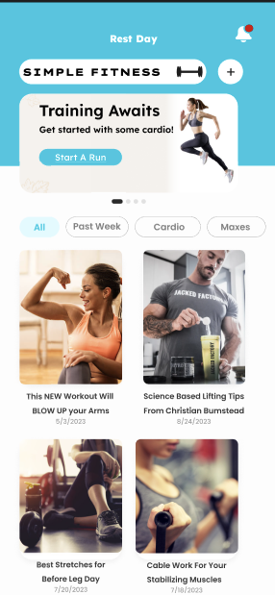

3.2 The user can check their notifications on the home page.

3.2.1. After the user checks their notifications, they can go back to the home page.

3.3. User then will select there type of work out they want to begin.

3.3 Once user selected work out, they will see the screen to the workout they selected.

3.3.1. When the user finishes the workout, they will see their end results.

3.3.2. When the user sees their results, they will even see their final results and a great job message.

3.4. The user will then input their results into the workout log.

3.5 User can go back in to results from previous workout to check results.

3.5. The user can also edit old workout logs, if need be.

3.6. The user can also check their final results from each workout session that they ever completed.

